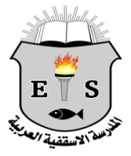
AES Easter Newsletter

Happy Easter!عيد فصح مجيد وسعيد!
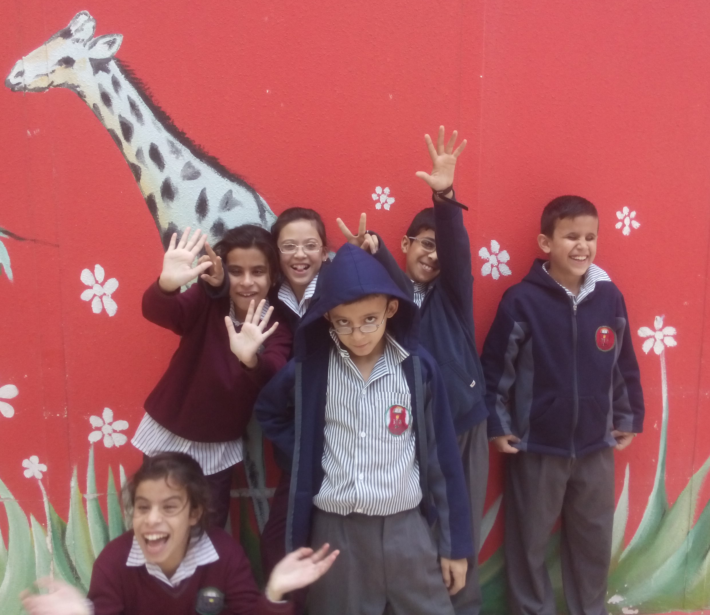

"It is true! The Lord has risen and has appeared to Simon."

Luke 24:34

All of us here at Arab Episcopal School are excited to announce that spring has arrived in Jordan! The sun is shining and the flowers are in full bloom. With spring being here that also means that Easter has arrived and with Easter arriving comes our Newsletter to give you a glimpse of what has happened here in Irbid, since the beginning of the year.
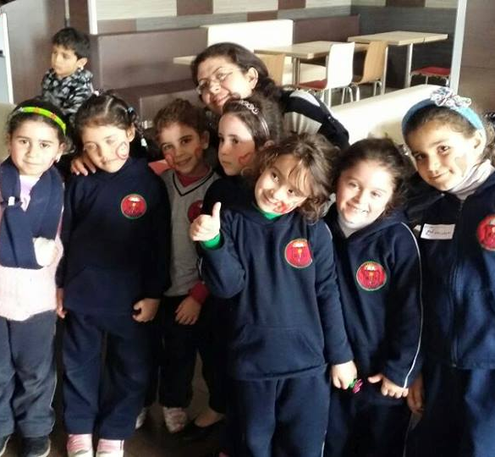
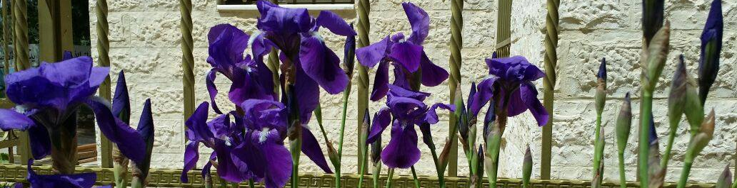
After the Christmas holidays, we had a week of exams to finish our first semester in January. We were surprised when one morning we awoke to snow; this snowstorm caused school closures nationwide for several days and so our exams and long-awaited vacation had to wait just a few more days. However, many students took the time off to play in the snow with their family and friends. After the snow melted and the exams ended, then finally began our four-week semester break; while the teachers and staff worked a few days without the students correcting the exam papers and preparing for our second semester which started on February 9th. Upon arrival back to school the students and teachers felt motivated for another semester!
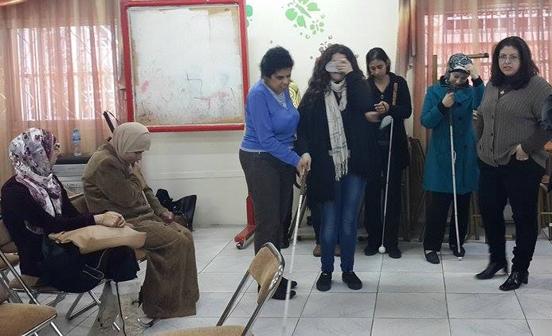
Visitors
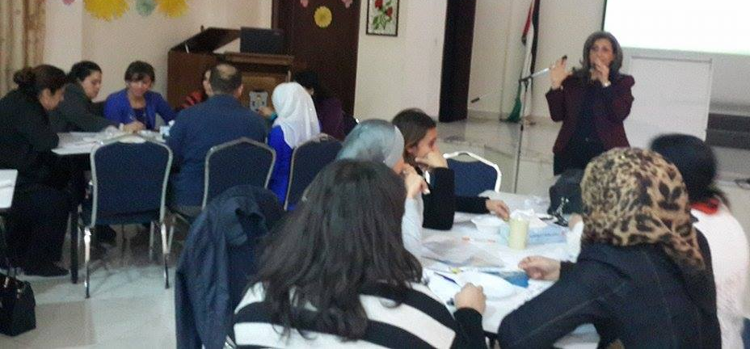
Beginning of February we had visitors from Germany. Deacon Gunter Hell came together with Lydia Zoubek for a few days to Jordan. Before the second semester started, our teachers participated in a three-day training course lead by Lydia. This training was to further enable our blind and visually impaired staff and students. The teachers were taught on how to use the walking cane as well as how to train our students in using the cane. On the last day of training our older students were given an introduction by Lydia on how to use the cane properly and how the cane could help them to become more independent. We were all very excited to have Gunter and Lydia visit us!
Mrs Reem Alfar also provided training for our teachers regarding creative teaching. Reem emphasized that it was important to make learning fun to help the kids retain information better. She also provided us with ideas on how to utilize different activities inside the classroom.

Peace March

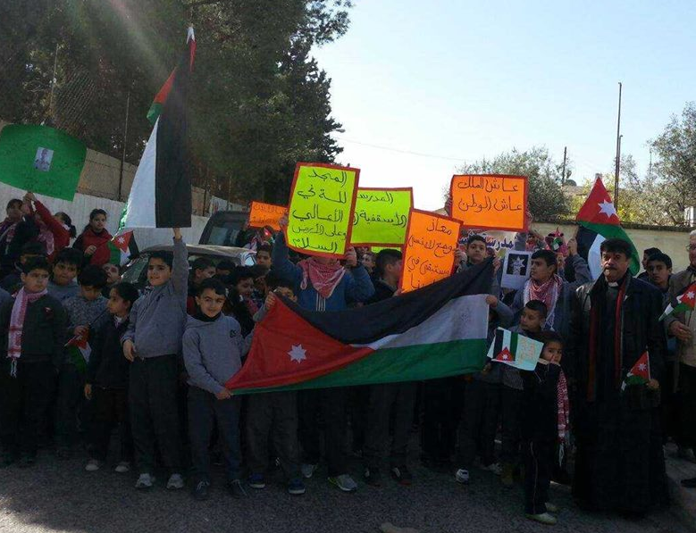
Unfortunately in February Jordanians received sad news regarding their pilot Muath Al-Kasaesbeh who had been taken hostage and was brutally killed by ISIS. All were deeply shocked by this cruel assassination. On February 10, our entire school along with the parents of the Anglican Church organized a march; we marched for peace to show our sympathy for Muath Al-Kasaesbeh and his family as well as, to show our support and loyalty to King Abdullah.
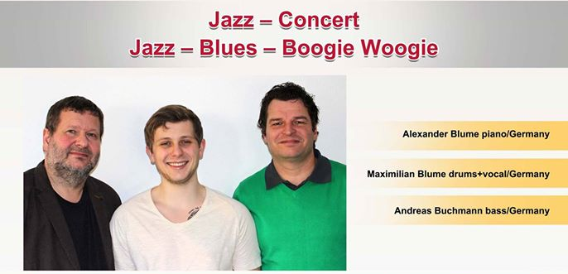
Jazz Concert
In March we had the privilege of friends visiting us from Eisenach, Germany: Alexander Blume, his son Maximilian Blume and his friend Andreas Buchmann. The Jazz trio not only came to visit Jordan but also to perform several concerts with all the funds going to Arab Episcopal School. The trio gave several concerts in Amman, Irbid and the surrounding areas. The audience was thrilled by the rather unusual jazz sounds and purchased many CD's from the musicians. Thus, showing once again that music is a language that is understood everywhere!
It was a great pleasure to host the three here in Jordan - Alexander and Maximilian visited us for the third time and Andreas for the first time. We are very grateful that they continue to support us in our aim to offer inclusive education for visually impaired and sighted students. You are always welcome! Thank you!
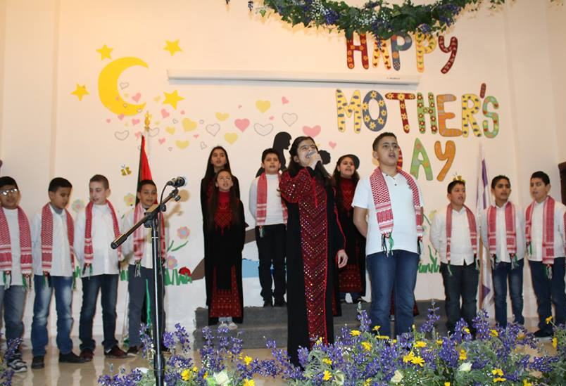

Mother's Day!

Mother's Day is celebrated here in Jordan on March 21st. To celebrate this day the families of the kindergarten to the 6th grade students came out to listen to the program that the students and teachers had worked so hard to prepare. The students sang songs varying from spring and the gratitude and love for their Mother's, in Arabic, English and French. There was also a small skit preformed by grade 3and several dances from several grades. After the program the children gave their mothers flowers, cards and a small gift. Many remained in the schoolyard, to eat sweets, drink coffee, to visit and take pictures.
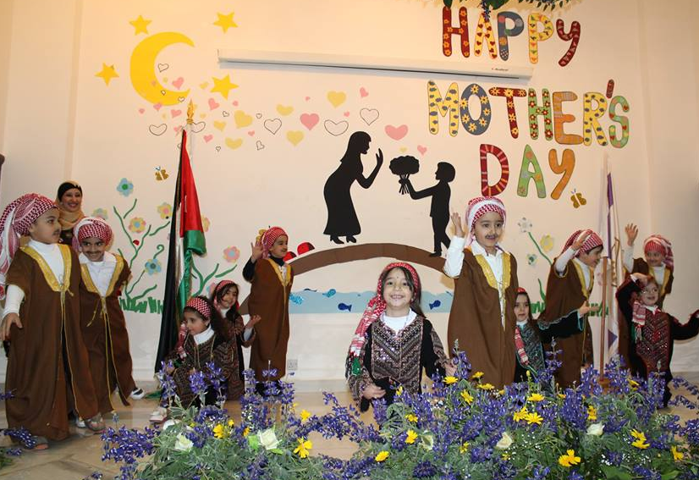
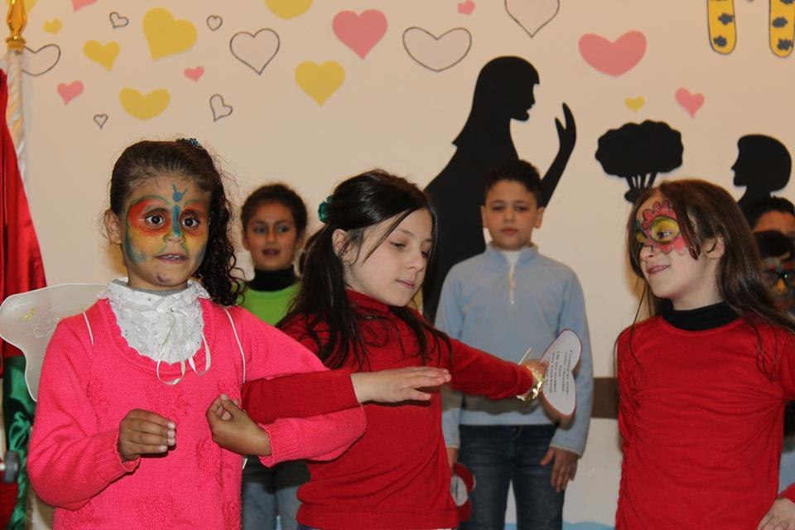

Student Exchange
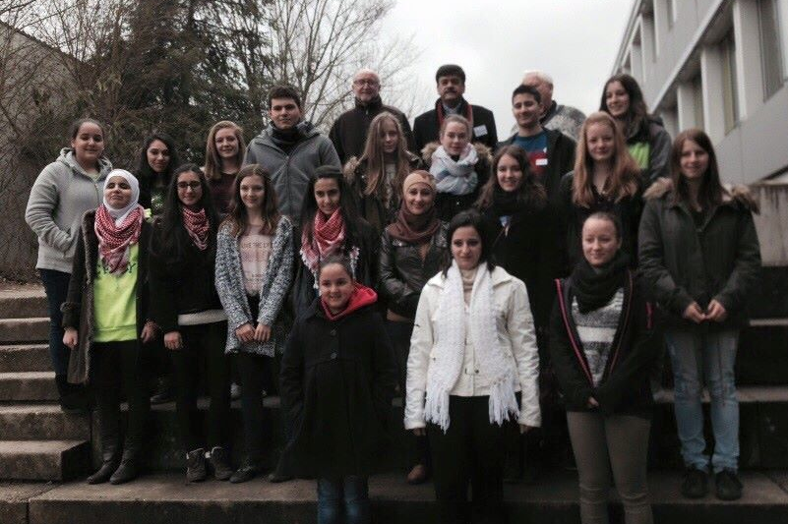
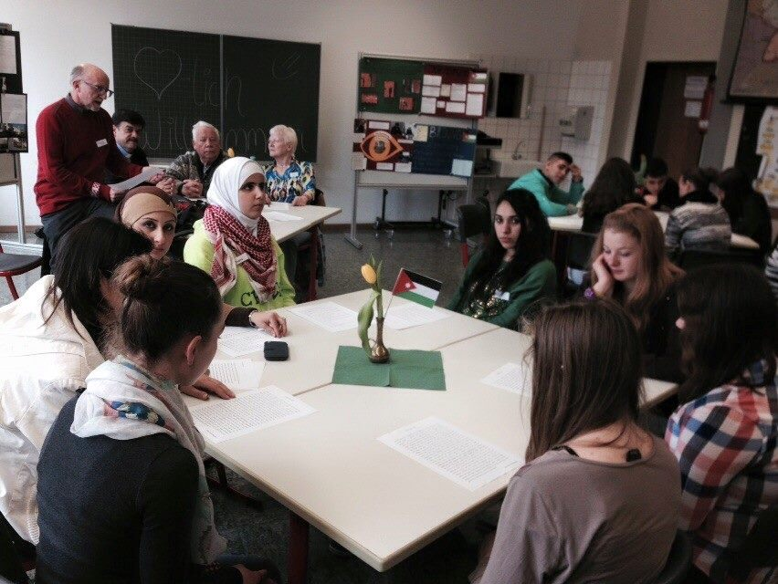
We were very pleased that for the first time our students were able to experience an exchange along with students from Germany of the Droste-Hülshoff School in Rottweil. On March 25, nine students (including 1 blind student) from the grades 8-10, along with Reverend Samir Esaid, teachers Hadeel Al Saleem and Safaa Khouri flew to Frankfurt. They spent three days in Rottweil and four more in Oberjesingen and returned on 1st of April. The students as well as the teachers greatly enjoyed their time in Germany and were happy to be able to experience and get to know a different culture. For many it was their first visit to Germany, or Europe, which made the trip very exciting and fascinating. We are glad that the students had the opportunity to visit another country, meet new people, and also to visit their schools. Thank you to all our friends in Germany for their kindness and hospitality! We Thank God that all have returned safely and we hope there will be many such encounters!
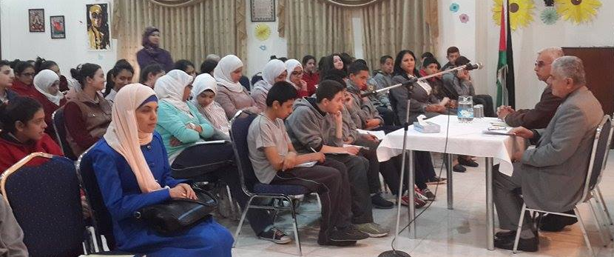
Social Intelligence
On April 4th we invited Dr Abed A Mohde Sawalh along with Dr Samir Alaboni from Irbid University to come and talk to our grade 7-10 students about Social Intelligence and the importance of it. They were informed that social interaction is key to their development and also important to live a healthy lifestyle.
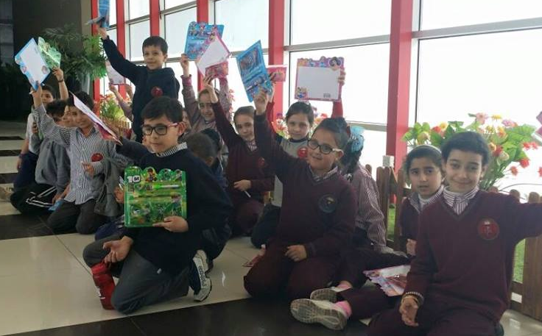
Field Trips!
All our students from KG 1 to Grade 3 had the opportunity to go to Arabella mall for a day and enjoy the games in the arcade. After a few hours at the arcade many students were hungry and so off to McDonalds we went to enjoy some lunch and the play area at McDonalds. The friendly staff also provided all our students with face paint. All in all the kids had a wonderful day taking a little break from their studies
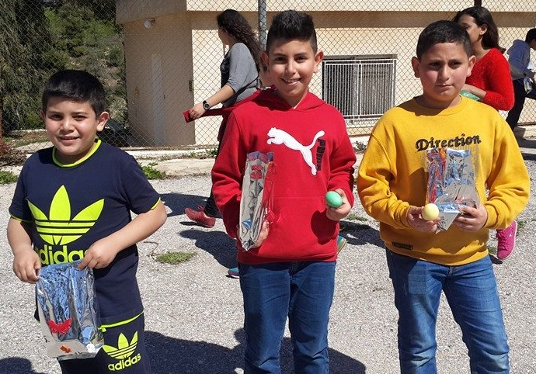
Easter Activities:
April 3rd: Easter egg hunt in Ajloun with 83 Christian students
April 8th: Easter egg coloring, crafts and snacks
April 15th: King Hussein Car Museum in Amman with Grades 4-6

"For what I received I passed on to you as of first importance: that Christ died for our sins according to the Scriptures, that he was buried, that he was raised on the third day according to the Scriptures."
1 Corinthians 15:3-4

Thank you!
Many thanks to all our friends and supporters! Thank you for all the donations and the existing interest in our work here in Irbid.
We wish you all a Happy Easter and God's blessings throughout this Easter season!

For more information please visit our website at: www.aeschool.org or our Facebook page at: www.facebook.com/ArabEpiscopalSchool.
Arab Episcopal School
P.O. Box 765
Irbid 211 10
Jordan
e-mail: stjohn_b@hotmail.com

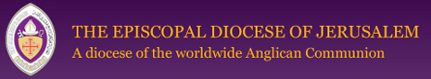

Arab Episcopal School is a part of the Diocese of Jerusalem the Episcopal Church in Jerusalem & the Middle East.
For more information please visit: www.j-diocese.org

